**JSR glass studio is a glass dealer and consultant. We specialize in consultancy, Glass solutions, fabrication, and installation of glass curtain walls for commercial buildings, retail malls, door, and windows for projects Delhi NCR.  With the experience of many years, our company provides the manufacturing and installation of products such as Decorative Glass, Modular Railings, Sliding Glass Doors, Slim Framed Shower Enclosures, and many more.**

**Our glasswork is customized based on our client's choice of texture, color, thickness, size, and design. At JSR Glass, we have been helping designers and homeowners all across India with customized glass panels, shower enclosure, sinks, bathtubs, and other functional glass art for years. Whether bent, curved, cast, sandblasted, or stained glass our artists combine colors and textures to create glass masterpieces that will enhance your walls, rooms, counters, and floors in an intriguing and visually exciting style.**

Our design-glass services offer great value thanks to high-quality products and cost-efficient pricing. Working closely with each client, our technical team ensures customers receive top-notch glass walls and panels on every order. Architects and designers looking for expert design, manufacturing, and delivery services consistently trust JSR Glass Technologies with their glass product projects.

Skilled technician 15

Happy clients 1026

Years of Experience 35

Finished Projects 3125

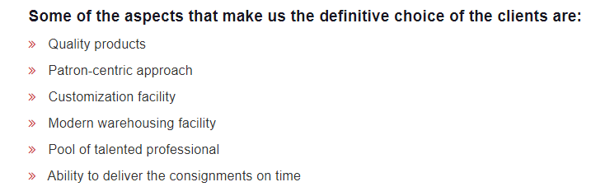

Convert this into chart format

